- How to Upgrade QuickBooks Desktop to a New Version
1. Please notify us 3 days ahead the date it will happen

2. Buy new QODBC Driver license (CD Key) if your current QODBC Driver license older than new QB version (e.g., QODBC Driver version is 2021 and new QuickBooks version is 2023). (Note: please talk to Bruce regarding the new license purchase)

3. Stop all integration flows before the upgrade

4. Let us know the QB upgrade is done to:

4.1 Schedule QB reconnection meeting if we have no direct RDC remote access to your QB server

4.2 Provide a date/time when QB can be switched to single user admin mode if we have RDC remote access to QB server and QB admin access to company file.

5. We will reconnect to QB company file (it will require QB admin password and switching QB into a single user admin mode for 30-40 minutes)

6. Wee will test new connection and restart integration flows

After you have finished installing your new version of QuickBooks. To ensure your user experience goes smooth, please complete the following steps when first using your new software the yellow welcome banners need to be dismissed.

Log in each QB user one time in each company file

Your company file will likely not be listed on the initial screen. Select the option to open/restore a company file, select the option to open a local file and click next. In the File Explorer window that appears, click the computer in the left pane, open the folder and select your company file (greenish-yellow icon, ending in QBW) and click open.

Enter the name and password of the QB user and logon to the company file QuickBooks will prompt you to update your company file to the new version. Please note, you will no longer be able to use your file on the old version of QuickBooks after the update. Please follow any prompts to backup and update your company file. Please save your backup to C:\Cloud Files to keep it with the rest of your data.

Once you have updated and the file opens, click one of the yellow banners to dismiss the bubbles

Click the “X” on the yellow bar that appears on the right-hand side.

Close the Company file.

Repeat steps1, 2, and 4-6 for each company file you will access. Also, each QuickBooks user will have to follow the procedure for each company file.

- As we move closer to completing the production flows, is there a plan for a final walkthrough or validation process? If so, what is the expected timeline for the final walkthrough? I want to ensure that we have a clear understanding of the steps that will be taken once the production flows are finalized.
The testing of the Utility Flows (from the data transfer level) accomplishes validation when transactions are created in QuickBooks/Salesforce. The Production Flow transfers the same data. There is an important distinction here; the InterWeave Solution is a live Solution in which changes, additions, new transactions can be added during the Subscription Year. We add a certain number of Smart+ hours in our engagement to make sure the first 15 to 30 days run smoothly and questions are answered quickly. We use Freshdesk as our ticketing system and Zoom is available every 2 hours of every day. Many customers make substantial changes 3 months out as they refine what other transactions they would like to see.

- Does the progress of the Production Flows depend on the the Customer team's testing and feedback of the initial build of the Community Portal (my assumption this is the InterWeave Portal), or will these steps proceed independently

They are mutually exclusive, but linked in that as testing sequences will be Salesforce to QuickBooks first, then ladder in the Community Portal transactions, and test again.

- Could you please provide us with a rough outline of the sequential steps involved in supporting Production Flows? Specifically, understanding the timing for actions such as binding, bulk loading, and data synchronization

We will be walking the Customer through the steps in supporting Production Flows, as every meeting we have will be a Training Session. In our help.interweave.biz website – InterWeave Help – The SmartIntegration Platform for CRM – there is the Knowledge Base and the Documentation for the Solution. We will be working with the Customer to Register them (and any others), so access to the Salesforce_QuickBooks Solutions Help & Training Guide.

Regarding Binding, Bulk Loading and Data Synchronization, the first two are detailed in our 8 Step Document attached. Binding is done right prior to going to Production, as we bind Accounts in Salesforce with Customers/Vendors in QuickBooks. We include Bulk Loading of data from QuickBooks to Salesforce for the current year and will show the Customer to load History. The data loading is regulated by the number of Salesforce API’s available – we work with the Customer in creating this schedule. Data Synchronization is part of the discussion at the Flow level and is part of the discussion when enabling the Production Flows.

- Establishing your QuickBooks Desktop Connection

We respect the security requirements of all our customers, including customers that have their QuickBooks Desktop applications installed in their secure or hosted environment.
The security of our customer’s data is our priority. InterWeave is hosted in a PCI compliant (level 2) environment and our architecture guarantees the full isolation of every customers data in our community servers. You also have an option of dedicated servers if you require it. There are two elements of the connectivity from our cloud-based servers to your QuickBooks Server.
(1) Runtime connectivity
We use the QODBC driver (part of QuickBooks Enterprise package) to connect to your QuickBooks. You can look at https://qodbc.com/supportfaq/ to get your self familiar with the driver. We need one port (recommended default port is 4500, but you can use any other port of your preference) opened for inbound and outbound secure (encrypted) communication (TCP). We will be connecting from one or two servers from our environment. IP addresses of these servers must be whitelisted in your firewall and a port forwarding rule to your local server must be created.
(2) Installation and managing your connection
2.1 You will create integration user in QuickBooks named interweaveQR (or with any other name) with Full Access role. The role can be changed as needed later.
2.2 You will create custom field AccountID in QuickBooks Customer or Vendor object. If you are planning to integrate Account Receivable section of QB, the custom field must be active for Customer. If you are planning to integrate Account Payable section of QB, the custom field must be active for Vendor as well.
2.3 If you do not have QODBC driver installed during your QB installation, you will install QODBC Driver (see https://qodbc.com/how-to-install-qodbc/ ). If you have QODBC driver installed, please make sure that it is updated to the lates version of the driver.
2.4 You need to create the DSN (Data Source Name) in QODBC on your server using driver “QODBC Driver for QuickBooks” (see Pic. 1). Please create 32-bit System DSN (not User DSN!). Please send us the name of DSN you’ve created.
Very important! Please turn the Optimizer option off for the DSN used for the InterWeave.

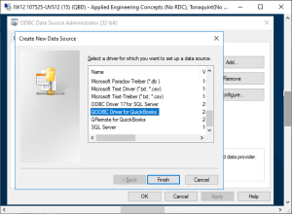
2.5 You need to connect to your QuickBooks company file(s) using the documentation from https://qodbc.com/connecting-to-quickbooks/. Please use DSN created in 2.4 and QB user created in 2.1 during your connection process.
2.6 For remote connectivity, you need to use the QRemote server component of the QODBC driver – see documentation in https://qodbc.com/using-quickbooks-remotely/. If you need assistance – we can provide a zoom session during which you’ll be setting up the connectivity. You will also be managing QuickBooks connectivity in the future using the documentation of the QODBC driver and InterWeave. To access the InterWeave Knowledgebase, go to https://help.interweave.biz/all-articles/. For more in-depth documentation, an InterWeave Support Agent can assist you with password creation for access.
2.7 We can also help with installing the QODBC based connectivity on your QuickBooks server. For this, we need to be provided with the direct RDP access to your QuickBooks server from the two or three IP addresses in InterWeave. These addresses must be whitelisted in your firewall and port forwarding rules created. Alternatively, we can use LogMeIn client to access a QB server (LogMeIn invitation must be provided). That access can be removed after the installation process is finished.
VERY IMPORTANT! We do not support any VPN based connectivity or MFA mechanisms that require installing components in our production environment. This is the violation of our security policies and cannot be used.
We can also fully manage your QODBC connectivity issues. In this case, the access is documented in the section 2.7.
As an alternative option, if you are interested, we can help you to move your QuickBooks Desktop to our hosting partners where you’ll be in the fully secure environment. The integration is setup by the partner and the connection is monitored by InterWeave.

- Custom BNF Field Mapping in InterWeave Solutions

BNF for mapping:
<mapping>::==<format_prefix><header_prefix><system1_API_name><delimiter><system2_API_name_or_value>
<format_prefix>::==”!”|”#”|”~”|””
“!” – date fields
“#” – number/currency fields
“~” – not nullable text fields
“” – no format_prefix – regular text fields

<header_prefix>::==”.”|””
“.” – applicable only for transactions objects for mapping starting from the second mapping; must be used for the fields from transaction header
“” – no header_prefix – must be always used for the first mapping in transactional mappings and for all non-transactional mappings; first transactional mapping always used for the fields from transaction header; subsequent transaction mappings (starting from the second one) without header_prefix are used for the fields from transaction line item
<system1_API_name> – API name of the field from the system 1, which credentials are specified in the lines #1 – #5 on the last page of the Company Profile
<system2_API_name_value> – API name of the field from the system 2, which credentials are specified in the lines starting from #6 on the last page of the Company Profile, or value (in case of the usage of the equal sign as a delimiter)

<delimiter>::==”/”|”\”|”:”|”=”
“/” – unidirectional mapping from system 1 to system 2
“\” – unidirectional mapping from system 2 to system 1
“:” – bidirectional mapping between system 1 and system 2
“=” – setting a static string value for the field of system 1
Note: not all cases are supported for all types of objects and all types of Interweave licenses.. If mapping is not supported please check with Interweave customer support.
Examples:
!Due_Date__c:DueDate – bidirectional mapping of the header field Due Date (date type) in the first mapping for some transaction.
!.Due_Date__c/DueDate – unidirectional mapping from the system 1 (e.g. Salesforce) to system 2 (e.g. QuickBooks) of the header field Due Date (Date type) in the second or subsequent mapping for some transaction
#Special_Cost__c\InvoiceLineCustomFieldCost1 – unidirectional mapping from the system 2 (e.g. QuickBooks) to system 1 (e.g. Salesforce) of the line item field Special Cost (currency type) in the second or subsequent mapping for some transaction

- How to Move Changes from Sandbox to Production in Salesforce

Methods
There are several methods for moving changes from a Sandbox environment to a Production environment, and the best method depends on the nature of the changes and the type of software you are using.
Here are some common methods:
Change Sets: If you are using Salesforce, you can use Change Sets to move customizations, configurations, and data from a Sandbox environment to a Production environment. Change Sets are a collection of metadata components that you can package together and deploy to another Salesforce org.
Metadata API: If you are using Salesforce, you can also use the Metadata API to move changes from a Sandbox environment to a Production environment. The Metadata API is a set of APIs that allow you to retrieve, deploy, create, update, or delete customizations for your Salesforce org.
Version Control Systems: If you are using version control systems like Git, you can version your code in a Sandbox environment and then merge it with the Production environment using a pull request.
Manual Deployment: You can also manually deploy changes by copying the files from the Sandbox environment to the Production environment. However, this method is not recommended because it can be error-prone and time-consuming.
It’s important to thoroughly test changes in the Sandbox environment before deploying them to Production to minimize the risk of negatively impacting Production data or functionality. Additionally, it’s also a good idea to have a backup of the Production environment before making any changes.

Steps
The steps to move changes from Sandbox to Production in Salesforce:
- Prepare the Sandbox: Make sure that your changes are thoroughly tested and ready to be deployed in the production environment.
- Export the Changes: Go to the Setup menu, then select Deploy and Export the changes from the Sandbox. This will create a .zip file containing all the changes you have made.
- Import the Changes: Go to the Setup menu in the production environment, select Deploy and Import the changes from the .zip file you exported from the Sandbox.
- Review the Changes: Salesforce will show you a summary of all the changes that will be made in production. Review the changes and make sure everything is correct before proceeding.
- Deploy the Changes: Click the Deploy button to move the changes from the Sandbox to production. You may need to schedule the deployment to take place at a specific time, or you can deploy immediately.
- Monitor the Deployment: Salesforce will display the status of the deployment process, and you can monitor the progress of the deployment.
- Verify the Deployment: Once the deployment is complete, verify that all the changes have been made correctly in the production environment.
Note: Always have a backup of your data in case of any unexpected errors.
Referrals:
https://developer.salesforce.com/forums/?id=9062I000000ILcUQAW
https://help.salesforce.com/s/articleView?id=sf.changesets.htm&type=5
https://youtu.be/jcBRFpzTdAY

- Prior to Binding, let's compare and decide either the CRM or the Financial System is Master

Prior to Binding, let’s compare and decide either the CRM or the Financial System is Master
So prior to your binding step, let’s focus on getting your data clean. Example below.
- For your Accounting System
  - Export all Customers to an Excel Sheet.
  - Export all Items to a separate Excel Sheet.
- For your CRM
  - Export all Accounts to an Excel Sheet.
  - Export all Products to a separate Excel Sheet
- Let’s compare the columns.
  - Copy Accounts to a 2nd Column next to Customers and run a compare.
  - In your InterWeave Solution, check to see – did you make CRM Accounts master over Accounting System Customers?
- If so, correct and update Accounting System Customers to match your CRM Accounts.
  - Do the same for Products.
- I assume the Accounting System Items are Master over the CRM Products, so update your CRM Products to match the Accounting System Items.
- Upload the updated Excel back up to SF and QB.
- Create a ticket and we will run binding.

- QuickBooks Desktop to QuickBooks Online Migration

The best time to do the switch is after business hours or on weekend so it will not interrupt your business. To switch to the QB Online I will need the following:
- To switch to the QB Online the following information must be provided:
  - Confirmation that QB Online file(s) is ready and in working order on the Intuit server
  - Admin credentials QBO file(s) – existing admin username (email) and password + file name will be enough (or you can create special admin user for integration using email – aumanets@interweave.biz)
  - A phone number to call you to get confirmation number from Intuit during connection to the file(s) (only in case if you will use existing QBO admin user)
- You will receive a Work Order for the QODBC driver for the QBO connection and Consulting Charge for your approval.

- Repetition Protection and your InterWeave Flows

To avoid unnecessary processing of the same records in bi-directional sync we use a mechanism called Repetition Protection. All records, which are last updated in your CRM by the CRM User that is specified in the company profile, are skipped when querying your CRM for the records ready to be processed. This mechanism is included into scheduled flows and bulk load utility flows. It is not applicable if integration is unidirectional or the operations from your Financial Application to your CRM are set to None.

- [QODBC] Error: 6210 - QuickBooks message: Account Period Closed, Cannot Update Through Services API

QuickBooks message: The account period has closed and the account books cannot be updated through through the QBO Services API. To resolve this error, manually update the items/fields in QuickBooks or open the accounting period for synchronization.

- How to force running Scheduled flow immediately

- Stop all scheduled flows.
- Set the Shift value (column in the middle of the table) to 0. Please remember the original Shift value.
- Start the flow.
- After it finishes – stop the flow and reset the Shift back to the original value.
- Start all Scheduled flows.

- How to Process a One-time Payment, Recurring Payment, Credit Memo & Refund

1. To Process a One-time Payment
In Section 1: Credit Card & E-Check (ACH) Payment Details (Real-Time and Scheduled)
In Edit Mode, select Payment Method and Manual CREDIT CARD Amount to Charge.
In Section 3: Bank Account and Credit Card Details
In Edit Mode, fill out either or both ACH and Credit Card information
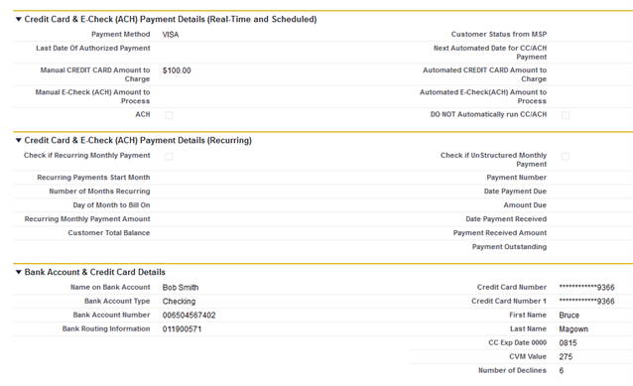
In this example, we have two buttons to select at the top of the SF Opportunity [Process CC or E-Check] – which is for Authorize.net or [PayPal CC Processing] – which is for PayPal. Click the button and transaction will be processed.
The result is a Transaction Record will be created in the Transaction Custom Object and the date will be filled in Last Date of Authorized Payment field:
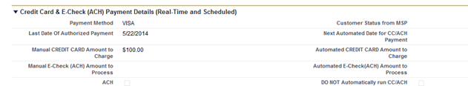
Transaction Object with Records (example):
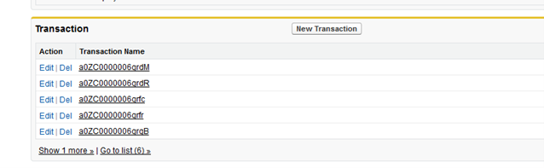
Transaction Record Detail
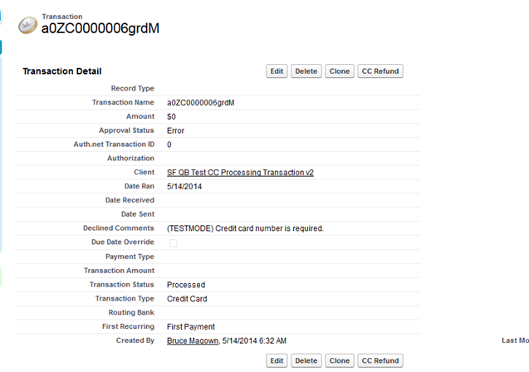
If an ACH Payment, fill out the ACH information in Section 1 and Section 3, enter the amount and check the ACH checkbox. Run as Credit Card process above.
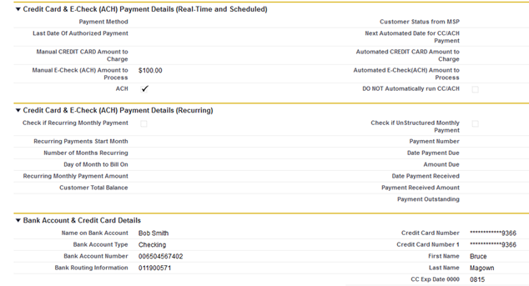

2. To Process a Recurring Payment
In Section 2: Credit Card & E-Check (ACH) Payment Details (Recurring)
In Edit Mode, enter data (value shown for an example):
Check if Recurring Monthly Payment Yes
Recurring Payments Start Month 5/22/2022
Number of Month Recurring 6
Day of Month to Bill On 10
Recurring Monthly Payment Amount 100.00

In Section 3: Bank Account and Credit Card Details
In Edit Mode, fill out Credit Card information
Your ACH/CC Payment Process flows (running every hour) will process this transaction on the correct date, number of months, day to bill on and amount – and create a Transaction Record under the Transaction Object.

3. To Process a Credit Memo or Refund
To process a Credit Memo/Refund, you open the Transaction Detail Record and click on the [CC Refund] button.


- Stripe documentation to find your Stripe Publishable and Secret API Keys

Please see Youtube to create API Keys
https://www.bing.com/videos/search?q=how+do+i+get+strip+api&docid=608003683988017776&mid=F75B927F2DF8D57D1386F75B927F2DF8D57D1386&view=detail&FORM=VIRE

- How To Switch Quickbooks Company File Onto Single User Mode

The following steps must be done to switch QB file in to single user mode:

Login in to your InterWeave Integration Manager (Flows Manager) using username and password you have (see #1 in InterWeave Integration Flows)
Stop all Scheduled flows (see #2 in Working with Flows), and wait until they turn all white (State = Stopped) (see #5 in Working with Flows)
Login to QB server and make sure QB file is not open by integration user interweaveQR (you can manually log this user out from the file if all flows are in Stopped State but the user did not log out automatically)
Switch QB file onto single user mode, and perform required tasks
Switch QB file back onto multi user mode
Log in to the Flows Manager and restart scheduled flows (see #1 in Working with Flows)

- To start integration setup process for QuickBooks Online version, we need the following information:

- SalesForce.com Organization Setup
  - An admin access to SF production org to set up integration custom fields and sections (InterWeave unmanaged package).
- QuickBooks Online Setup
  - QB admin credentials and company file name to connect the company file to InterWeave community server.
Also, I need the phone number I can call to get your authorization when connecting to the QB file and time when you are available.

- Working with the InterWeave Freshdesks Ticketing System
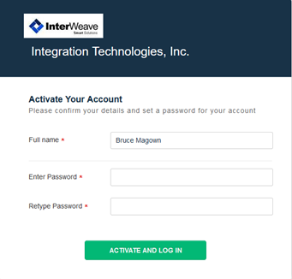

Working with the InterWeave Freshdesks Ticketing System
To create a Ticket up on InterWeave’s Freshdesk Ticketing system, please follow below.
You first go to this URL – Support : Integration Technologies, Inc. (freshdesk.com)
At the top of this page, click on “New Support Ticket”, as you have not registered yet in our Freshdesk.
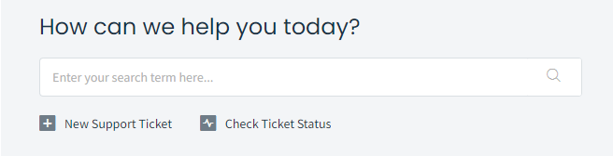
You can enter here your email address, name, title and description of what you would like performed.
You will then receive an email from InterWeave notifying you that an account has been created for you, so click on the link to activate your account and select a password.
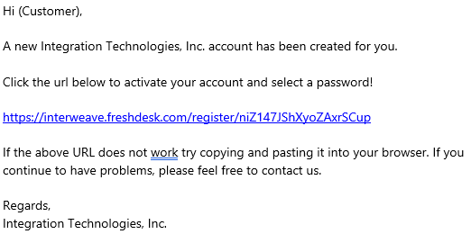
When you click on this URL, you will brought to this page.
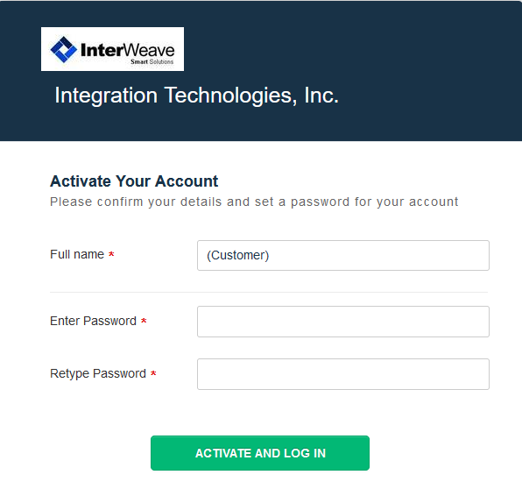
Add your Name and Password and you are all set.
You are now registered and can monitor the progress of your ticket.

- The Integration Transaction Log from the Server

Below is an example of a IW Transaction Flow Daily Log report for 2022-05-31. This is a once a day file; It’s a collection of logs.
As the customer receives error emails in real time, when your Solution Flow is running. If you need more information, you can reference the log using time stamp as the search criteria. Go to Edit/Find and enter the time stamp.
When the file is sent you to via email (this is if you selected it in your Solution Configuration), you can open it with Wordpad or Notepad (it is in .erl format).
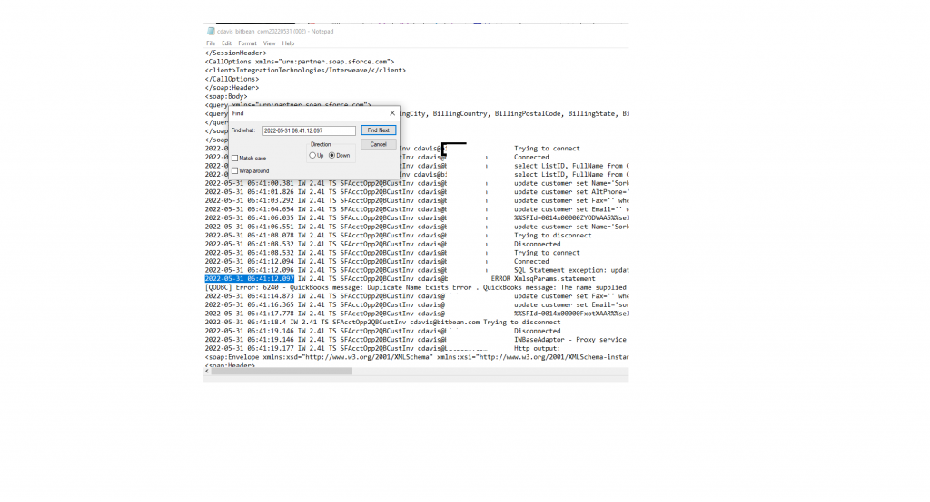
The log format is for the Integration Administrator, who is trained during the Integration process.

- How to catch up with missing data using Bulk Load Flow

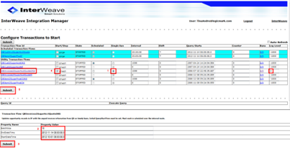

How to catch up with missing data using Bulk Load Flow
To restart flow that is behind for more than 1-2 days it requires to restart it from current date and use bulk load utility flow to catch up with previous data. Restarting scheduled flows from the current date/time is to avoid integration server overload with back log of data that CANNOT be transferred by scheduled flow.
You need to run particular DR (Date Range) or DRS (Date Range + batch Size) bulk load utility flow (with DR or DRS at the end of its name) to catch up with missing data. Bulk load flows are designed to move big amount of data without integration server overload. I have attached the instruction on how to run bulk load flow.
In order to bulk load only the Items of the specific type the prefix to the Start Date parameter must be used. Here is the list of prefixes:
- I – inventory items only
- N – non-inventory items only
- S – service items only
- G – group items only
- L – all item types except group items
- R – all item types except inventory items
Examples for Start Date Field (as for most of the cases, if Date includes time, then modified timestamp is used; otherwise the created one):
- I2023-01-01 – load all Inventory items that were created on or after 2023-01-01
- S2023-01-01 09:00:00 – load all service items that were last modified on or after 2023-01-01 09:00:00
Catch-up Procedure Steps:
- Stop scheduled flows and change their Query Starts date to current date if it is older than 1-2 days
- Use DR/DRS bulk load flow to catch up with previous data
- Run one bulk load flow at a time
- Restart scheduled flows after bulk loading is done

- Binding and Bulk Loading


Binding and Bulk Loading
Accounts
Binding is a process of linking existing records in Salesforce and QuickBooks. It just populates one or two fields in existing records. It never moves any new records between systems.
Binding process runs in both direction but do not sync anything – it is not reading any data or writhing any data other that 2 fields below. It only binds existing records to eliminate massive duplicates after scheduled flows are started. Binding flow populates one field (custom field AccountID) in QuickBooks (pass #1) and one field (custom field QuickBooks Full Name) in Salesforce(pass #2). Usually pass #1 is 90% of time and pass #2 is 10% of time.
Products
Usually products do not require binding – unless you have in QuickBooks items with parent items and in Salesforce – items w/o parent items.

Bulk load
To restart flow that is behind for more than 1-2 days it requires to restart it from current date and use bulk load utility flow to catch up with previous data. Restarting scheduled flows from the current date/time is to avoid integration server overload with back log of data that CANNOT be transferred by scheduled flow.
You need to run particular DR (Date Range) or DRS (Date Range + batch Size) bulk load utility flow (with DR or DRS at the end of its name) to catch up with missing data. Bulk load flows are designed to move big amount of data without integration server overload. I have attached the instruction on how to run bulk load flow.
In order to bulk load only the Items of the specific type the prefix to the Start Date parameter must be used. Here is the list of prefixes:
- I – inventory items only
- N – non-inventory items only
- S – service items only
- G – group items only
- L – all item types except group items
- R – all item types except inventory items
Examples for Start Date Field (as for most of the cases, if Date includes time, then modified timestamp is used; otherwise the created one):
- I2023-01-01 – load all Inventory items that were created on or after 2023-01-01
- S2023-01-01 09:00:00 – load all service items that were last modified on or after 2023-01-01 09:00:00
Catch-up Procedure Steps:
- Stop scheduled flows and change their Query Starts date to current date if it is older than 1-2 days
- Use DR/DRS bulk load flow to catch up with previous data
- Run one bulk load flow at a time
- Restart scheduled flows after bulk loading is done

- Let’s first start with - Who is FlexQuarters and what is QODBC



Who is FlexQuarters and what is QODBC.
The InterWeave integration is rather on the sophisticated side, but to bring this down to plain talk; it implements the Customers business process and work-flow with the data being brought back and forth from QuickBooks to Salesforce, and Salesforce to QuickBooks.
In regards to your request for information on the QODBC Connector, please see below.
Let’s first start with Who is FlexQuarters.
FLEXquarters.com Limited is an Intuit Partner that designs tools to automate connection and integration with your QuickBooks. This is the company who created the QODBC Driver (which is OEM’d by Intuit and is in your QuickBooks Desktop application right now). The distinction is that it is in “Read-Only” mode. The only function InterWeave does is upgrade your QODBC license to “Read/Write”, so InterWeave can read and create records in your QuickBooks.
This allows Read/Write communication now with your Salesforce and your QuickBooks.
For a technical definition, please see below.
What is QODBC?
QODBC is an ODBC driver (DLL) for QuickBooks format files. QuickBooks stores its data in its own proprietary DBMS file format. This driver allows users of any ODBC compliant front-end application to read and write data contained in QuickBooks format files similarly to any other ODBC enabled database.
QODBC works by accepting SQL commands from applications through the ODBC interface, then converting those calls to navigational XML commands to the QuickBooks DBMS and returning record sets that qualify for the query results. This driver is not a Client/Server product, but rather communicates directly with the QuickBooks application as it runs. QuickBooks is a flat file database, and this driver will not change it into a relational database, so keep that in mind when developing with this driver. QODBC acts as a ‘wrapper’ around the Intuit SDK so customers can finally get at their QuickBooks data using standard database tools, speeding development time.

- Salesforce Password Policies

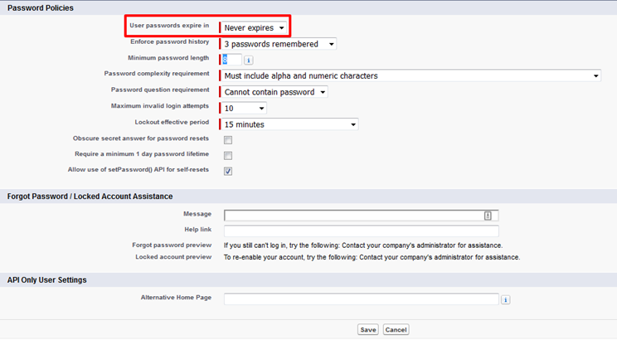

Salesforce Password Policies
Set the password restrictions and login lockout policies for all users.


- How to Change SalesForce Credentials in InterWeave Company Profile
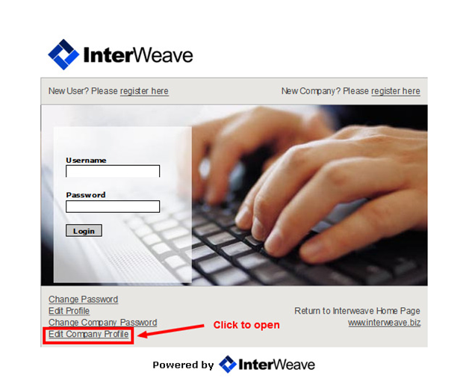

How to Change SalesForce Credentials in InterWeave Company Profile

The sequence of the procedure
1. Log in into Integration Flows Manager: Go to http://www.interweave.biz/ and click on Customer Login link.
2. Stop any started scheduled flow(s) if not stopped
3. Go to SalesForce and change your credentials/password for SF integration user
4. Log out from Integration Flows Manager
5. Log in into Edit Company Profile (see screenshots below)
6. Change your SF credentials on the last page in your Company Profile (login using Edit Company Profile link) and click Finish button to save the change
7. Log in into Integration Flows Manager
8. Restart scheduled flows
5.1 Go to http://www.interweave.biz/, click on Customer Login link and Log in to Edit Company Profile

5. 2 Populate Interweave account credentials and log in to company profile
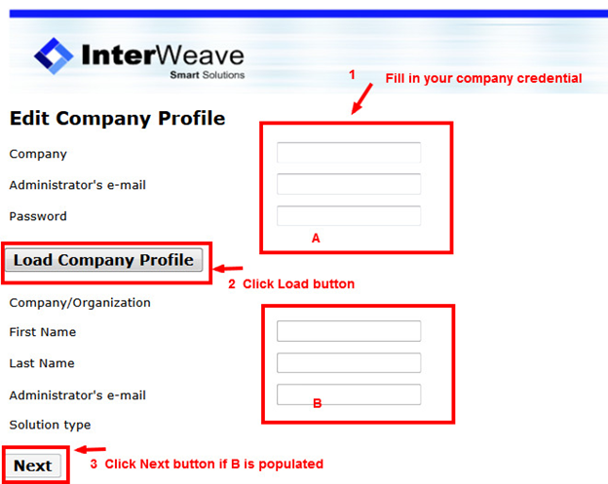
6. Change SF credentials on the last page of the profile and save changes
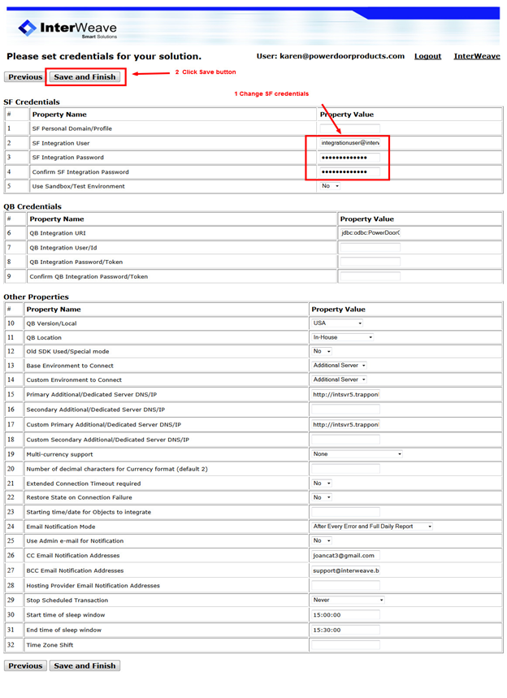

- How to Use Bulk Load Utility Transaction Flows in the InterWeave Integration Manager

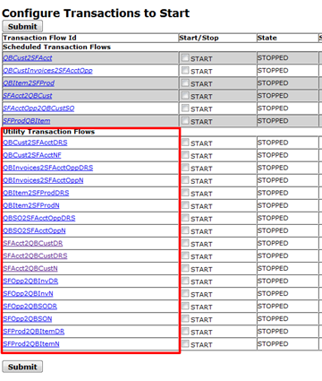

How to Use Bulk Load Utility Transaction Flows in the InterWeave Integration Manager
NOTE: Turn off all Scheduled flows before starting Utility flows!!!

UTILITY FLOW DEFINITION
There are 2 types of Utility flow:
1. Bulk Load flows (with DR or DRS at the end of the flow name)
DR = Date Range or DRS = Date Range & Size (Check radio button “Scheduled”)- for Bulk Load by a period (Date Range) and batch size (S).
2. Single transaction flow (with N or NF at the end of the flow name)
N = Name/Number (Check radio button “Single Run”) – for one time particular transaction sync or testing (Account/Opportunity/Product/Quote… etc.)
To use a Utility flow, you will need to:
1. Log in into your Interweave Integration Manager.
2. Run one of Utility Transaction Flows (located in a lowest, second section of the screenshot below).

Please refer to this video for details: http://www.youtube.com/watch?v=S7crX_OEEpc&feature=channel&list=UL
(Production and Utilities Flows are shown on 4th min of the video)

HOW TO RUN BULK LOAD FLOWS
Bulk load flows are marked with a suffix DR or DRS at the end of flow’s name.
Below are some flow examples for SF to QB direction:
1. For Customers: SFAcct2QBCustDRS
2. For Items: SFProd2QBItemDR
3. For Invoices: SFAcctOpp2QBInvoicesDR
4. For Sales Orders: SFOpp2QBSODR
5. For Sales Receipts: SFOpp2QBSRDR
6. For Vendors: SFAcct2QBVendorDR
7. For Purchase Orders: SFOpp2QBPODR
Below are some bulk load flow examples for QB to SF direction:
1. For Customers: QBCust2SFAcctDRS
2. For Items: QBItem2SFProdDRS
3. For Invoices: QBInvoices2SFAcctOppDRS
4. For Sales Orders: QBSO2SFAcctOppDRS
5. For Sales Receipts: QBSR2SFAcctOppDRS
6. For Vendors: QBVend2SFAcctDRS
7. For Purchase Orders: QBPR2SFAcctOppDRS

TO RUN UTILITY FLOWS, YOU WILL NEED TO
1. Login to your Interweave Integration Flows Manager:
Go to http://www.interweave.biz/ and click on Customer Login link
2. Stop any started scheduled flow(s) (the flows will turn white when stopped)
3. Click on the flow you want to do a bulk load with. The flow’s Property table will open below
4. Fill in 3 fields for RDS flow or 2 fields for DR flow in the utility flow’s Property table and submit
a) BatchSize
b) EndDateTime
c) StartDateTime
5. Set Counter of the flow (second column from the right) to 0 (if it is not equaling 0)
6. Check Start checkbox (second column from the left) and auto-refresh checkbox (right top corner of the page – it will refresh manager’s page every 5 seconds)
7. Click Submit button to run the flow
8. Monitor flow results in a log (the log is accessible by clicking on highlighted number/number (e.g. 0/0) in Runs column for this flow)
9. Restart scheduled flow(s) if needed after the bulk load is completed
10. Logout from Integration Manager
Please refer to this video for details: http://www.youtube.com/watch?v=S7crX_OEEpc&feature=channel&list=UL
(Production and Utilities Flows are shown on 4th min of the video)

How to fill in Property Values
- Click on the Flow’s name
- Fill in parameters
- Click Submit button (the button below the Properties table only!)
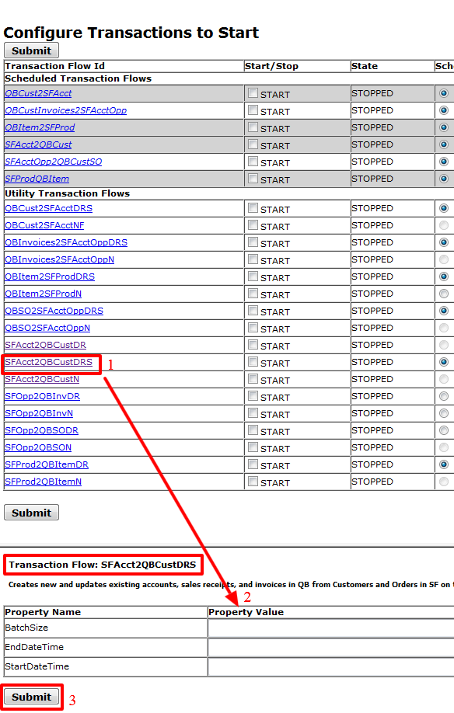
All DRS flows have 3 parameters:

(1) BATCH SIZE
Recommended values for QB to SF direction:
1. For Customers and Vendors: QBCust2SFAcctDRS = 75 if customer’s contacts also are loaded; 100 otherwise
2. For Items: QBItem2SFProdDRS = 25
3. For Invoices: QBInvoices2SFAcctOppDRS = 150 (line items)
4. For Sales Order: QBSO2SFAcctOppDRS = 1-3
For SF to QB direction batch size is controlled by SF. It is recommended to use 100 for any flow.
For SFProd2QBItemDR flow:
Batch Size = empty to run flow by LastModified Date (to sync mass updates in SF)
Batch Size = number to run flow by Created Date (to sync mass creates in SF)

(2) INTERVAL
StartDateTime, EndDateTime – interval that is supposed to be loaded.
24 hours’ clock should be used.
Common Formats:
1. SF to QB direction Date/Time format (UTC): 2022-01-30T00:00:00.0Z(YYYY-MM-DDTHH:MM:SS.0Z)
2. QB to SF direction Date/Time format: 2022-01-30 00:00:00 (YYYY-MM-DD HH:MM:SS), or C2022-01-30 00:00:00 (CYYYY-MM-DD HH:MM:SS) – for Invoice Only!
3. For “QuickBooks Online” QB to SF direction Date format: 2022-01-30 (YYYY-MM-DD)
Format Usage:
1. For history data bulk load: YYYY-MM-DD !!!
a) For Customers and Items as a Created Date
b) For Invoices, Bills, Credit Memo as a Transaction Date
2. For history data bulk load or a catch up with current missing data:
a) YYYY-MM-DD HH:MM:SS – Last Modified Date/Time for all types. Exclusively used to bulk load: Vendors, Sales Orders, Sales Receipts, Purchase Orders from QB to SF only.
b) CYYYY-MM-DD HH:MM:SS – Time Created for Invoice and Sales Order = Add letter C ONLY in StartDate/Time, EndDate/Time must be without letter C!
3. Star (*) – for an unlimited period (QB to SF only!). Must be used in Start and End DateTime (Does not supported for Transactions – Invoices, Sales Receipts, Sales Orders etc. and Vendors!)

(3) INTERVAL NOTE FOR INVOICE FLOW ONLY
a. If you put to StartDate and/or EndDate just a date (YYYY-MM-DD) – SF Opportunity’s CloseDate is used
b. If you put to StartDate and/or EndDate a timestamp (YYYY-MM-DDTHH:MM:SS.MZ) and BatchSize is empty – SF Opportunity’s LastModifiedDate is used
c. If you put to StartDate and/or EndDate timestamp (YYYY-MM-DDTHH:MM:SS.MZ) and BatchSize is not empty – SF Opportunity’s CreatedDate is used

How to Bulk Load Multiple Sales Orders and Invoices using their Numbers:
Invoices:
Direction: from QB to SF
Flow Type = DRS (DR can be for Invoices)
BatchSize = 0
Scheduled = On
Direction: from SF QB
Flow Type = N flow (e.g., SFOpp2QBInvN)
Scheduled = On
Sales Orders:
QBSO2SFAcctOppDRS – Put pipe separated values into StartDateTime field using the format:
243;123;893;345;
Invoices:
QBInvoices2SFAcctOppDRS – Put pipe separated values into StartDateTime field using the format: 174|179|190|
Credit Memo: No

EXAMPLES
EndDateTime=YYYY-MM-DD (or YYYY-MM-DD HH:MM:SS) – to load all records set something in the future (e.g. 2022-01-01 00:00:00) or exact date and time for specific period (e.g. 2012-10-01 00:00:00)
StartDateTime=YYYY-MM-DD (or YYYY-MM-DD HH:MM:SS) – to load all records set something in the past (e.g. 2000-01-01 00:00:00) or exact date and time for specific period (e.g. 2012-01-21 00:00:00)
When each of those flows is started first time – Counter (second column from the right) MUST be equal to 0.
How to Bulk Load SF Accounts with Special Characters:
Use SFAcct2QBCustN flow and replace Account name with special char (like this name “Locklear & Associates”) with @SF ID #
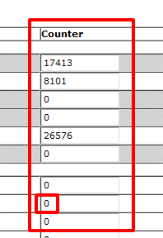
If you want to stop bulk load – just remember all 3 parameters and Counter to resume later.
It is recommended to run bulk loads after hours or on the weekend.

GENERAL NOTES
1. SF to QB and QB to SF direction flows for any type of bulk load require to set Permitted sync Operation to Create Only in Profile (temporary change)
2. SF to QB direction flows require to set Permitted sync Operation for opposite direction to None in Profile (temporal change)
3. QB to SF direction flows do not require to set Permitted sync Operation for opposite direction to None (no change in Profile)
4. Before flow is started, it is beneficial to have the auto-refresh checkbox checked – this will refresh the manager’s page every 5 seconds so you can monitor the progress of the flow. The Counter column will show you the number of already finished runs – every run is equal to a number of transaction defined by BatchSize. It will stop when there are no more records to process.
5. Every new bulk load requires Counter (second column from the right) to be reset to 0.
6. The Counter shows how many batches of size “batch size” are loaded.
7. If you want to stop a particular load and then start from the same place – you need just to restore the Counter to the value you’ve stopped the load with.
8. Remember that utility flows parameters are lost after logging out.
9. If you bulk loading QB Customers/SF Accounts with Contacts then BatchSize cannot be more than 4 otherwise you will get a LIMIT_EXCEEDED error:
“Query executed; Result= sf:LIMIT_EXCEEDEDLIMIT_EXCEEDED: Cannot have more than 10 chunks in a single operation. Please rearrange the data to reduce chunking.LIMIT_EXCEEDED Cannot have more than 10 chunks in a single operation. Please rearrange the data to reduce chunking.”
10. If you restarting any SF to QB DR/DRS flow – you must clear Return String! (Return String is a Property on top of the batch size in the lower frame. It is not there when you first time is configuring flow (setting up Batch Size, Start Date and End Date). It appears after first run and contains SF Query Locator. If you need to restart DRS flow – you must clear it or log out and log in.
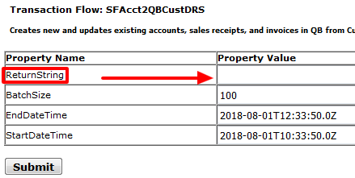
We keep their request locator from SF, but they (SF) have a mechanism that expires the session after some timeout period. Using the old query locator is causing “Query Locator” error. This error is very rare. In any case, we will also put a locking mechanism in the infinite run of the flow after such error.

- How to Use Single Run Utility Flows in InterWeave Integration Manager
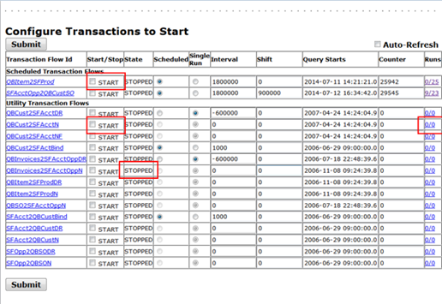
NOTE: Turn off all Scheduled flows before starting Utility flows!!!

Utility Flow Definition
There are 2 types of Utility flows:
1. Single transaction flow (with N or NF at the end of the flow name)
N = Name/Number (Radio button “Single Run” is checked by default) – for one time particular transaction sync or testing (Account/Opportunity/Product/Quote… etc.)
Note: Single utility flow does not support ampersands (&) and quotes (“)in the name.
2. Bulk Load flows (with DR or DRS at the end of the flow name)
DR = Date Range or DRS = Date Range & Size (Radio button “Scheduled” is checked by default) – for Bulk Load by period (Date Range) and batch size (S).

How to Use Single Run Utility Flow
NOTE: Single utility flow does not support ampersands (&) and quotes (“) in names.
In order to use Utility flows you will need to:
1. Login into your ISP (Interweave Integration Solution) flows manager
2. Run one of Utility Flows (second low section of the screen) to test
Please refer to this video for details: http://www.youtube.com/watch?v=S7crX_OEEpc&feature=channel&list=UL
(Scheduled and Utilities flows are shown on 4:02 min of the video)

Flow Usage
Single Transaction Utility flows are marked with N, NF or FN at the end of flow’s name. Utility flows are used only for testing, binding, initial bulk load and catch up with missing data.

Starting/Stopping Utility flow
1. To start a flow, check the checkbox “START” on the same row as the flow name, and then click the “Submit” button at the top or bottom of the table with flows.

2. The currently working active (State=RUNNING) flow is highlighted in Magenta. Active (State=STARTED) flow in a waiting mode is highlighted in Blue.
3. To keep checking the status of running flows, refresh the page or just click “Submit” when NO checkboxes are selected – that is equivalent to refreshing the page.
4. To stop a flow, check the checkbox “STOP” on the same row as the flow name, and then click the “Submit” button at the top or bottom of the table with flows.
5. Stopped flow became white in color (State=STOPPED). If flow became Yellow after stopping it, user have to wait until it finishes the current run and became white to use it again.

Running Utility flow
1. Fill in the Property Value of particular transaction (Property Name) in the second table below the Utility Transaction Flows table *
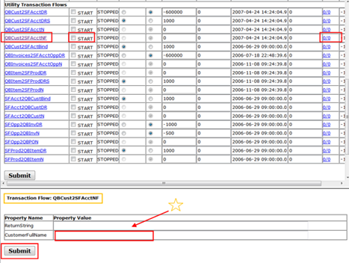
2. Check “START” checkbox and click “Submit” button to run the flow
3. Monitor the flow execution by refreshing browser’s screen or check AutoRefresh check box (top right) and click Submit – it will be refreshed automatically every 5 seconds.
You can also see the flow sync results in a log in Runs column for this flow. Click on Runs link (initially looks like 0/0; left side shows successful run/right side shows unsuccessful runs) to open new browser’s tab with flow’s log and read if there are any errors.
4. Click on Logout link on the top right to log out from Integration Manager after testing is completed
*Example:
Property Name Property Value
CustomerFullName XXXXXXXXX

Running Multiple Invoices
*You can use pipe separated format to run multiple invoices by Ref Number:
11111|22222|33333|44444|

- Working with Scheduled (Production) and Utility (Test & Bulk Load) Flows in InterWeave Integration Manager Portal for QuickBooks

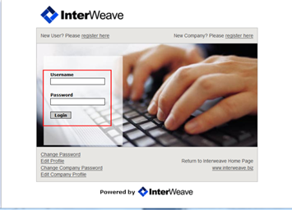

Working with Scheduled (Production) and Utility (Test & Bulk Load) Flows

InterWeave Integration Basics
InterWeave works based on “flows”, which are batch jobs importing a subset of data from one system to another.
Flows are running between customer’s CRM (e.g. Salesforce.com) or website and InterWeave community server on one side, and InterWeave community server and customer’s QuickBooks server on the other side.
InterWeave uses CRM user (e.g. Salesforce.com) with admin capabilities.
InterWeave uses dedicated QuickBooks user with admin capabilities, created specifically for integration. You must not login to QuickBooks using InterWeave user. It is not required and can even be harmful.
QuickBooks connectivity is fully customer’s responsibility if QuickBooks server located in-house.

The Setup of customer’s QuickBooks server
1. QuickBooks server’s user is logged on all the time you want integration to work. This Windows user is the user under which QuickBooks application and QODBC Driver (with QRemote server app) or PCS (with Apache Tomcat server and Integration server) have been installed.
2. QuickBooks application and QRemote server (remote connector or Tomcat server for PCS solution) must be started and running.
3. QuickBooks must be in a multi user mode.
4. QuickBooks company file has to be closed.
5. No pop up window is allowed in QuickBooks including company file log in window.

InterWeave Integration Flows
1. Use an InterWeave administrator user (integration user) credentials to log in the InterWeave Flows Manager – the main Login screen (two central fields for username (email) and password) on the ISP page.
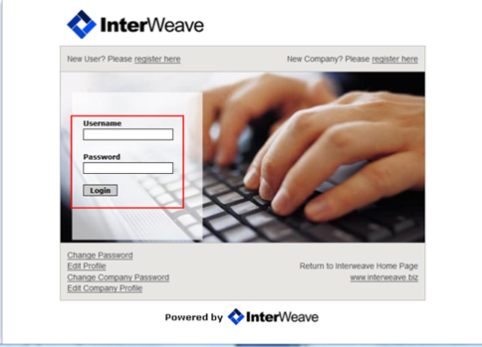
2. You should see a table with a top partition containing a list of Scheduled flows and a bottom partition containing a list of Utility Flows currently available, with a few checkboxes and other fields in each row.
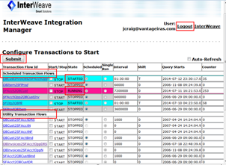
3. Scheduled flows (top table) are used for daily integration (production) and cannot be used simultaneously with Utility flows. User must stop scheduled flows before using utility flow. Only one utility flow can be used at a time!
4. Utility flows (bottom table) are used only for testing, binding, initial bulk load and catch up with missing data.
Utility flows are of three types:
(1) Binding flow (with Bind at the end of the flow’s name) is used for one time binding between two systems. Example: SFAcct2QBCustBind
(2) Bulk load flow (with DR or DRS letters at the end of the flow’s name) is used to bulk load data by period (Date Range) and batch size (S). Bulk load flows are designed to move big amount of data without integration server overload. Examples: QBCust2SFAcctDR/SFAcct2QBCustDR or QBInvoices2SFAcctOppDRS
(3) Single Run flows (with letters N or NF at the end of the flow’s name) is used for one time particular transaction sync or testing. Examples: QBCust2SFAcctNF/SFAcct2QBCustN or QBInvoices2SFAcctOppN
Note 1: Single utility flow does not support ampersands (&) and quotes (“) in the name.
Note 2: Interval is in milliseconds (1 second = 1000 milliseconds)

Working with Flows
1. To start a flow, check the checkbox “START” on the same row as the flow name, and then click the “Submit” button at the top or bottom of the table with flows.

2. The currently working active (State=RUNNING) flow is highlighted in Magenta. Active (State=STARTED) flow in a waiting mode is highlighted in Blue.
3. To keep checking the status of running flows, refresh the page or just click “Submit” when No (0) checkboxes are selected – that is equivalent to refreshing the page.
4. To stop a flow, check the checkbox “STOP” on the same row as the flow name, and then click the “Submit” button at the top or bottom of the table with flows.
5. Stopped flow became white in color (State=STOPPED). If flow became Yellow after stopping it, user have to wait until it finishes the current run and became white to use it again.
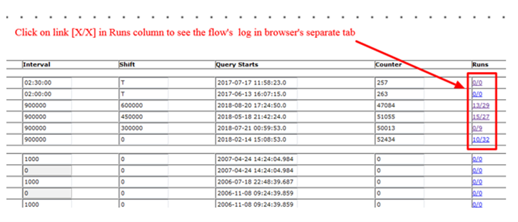

How to catch up with missing data
If you stopped a Scheduled Transaction Flow(s) or it stopped somehow else for a few days, you need to (1) make sure connection to QB company file is intact and (2) restart flows. To restart a Scheduled Flow, you do need to change the Query Starts field value to current date.
To restart flow that is behind for more than 1-2 days it requires to change the Query Starts field value to current date and restart it and use bulk load utility flow to catch up with missing data.
Restarting scheduled flows from the current date is needed to avoid integration server overload with back log of data that also CANNOT be transferred by scheduled flow.
You need to run particular DR (Date Range) or DRS (Date Range + batch Size) bulk load utility flow (with DR or DRS at the end of its name) to catch up with missing data. Bulk load flows are designed to move big amount of data without integration server overload. I have attached the instruction on how to run bulk load flow.
Please ALWAYS stop scheduled flows and change their Query Starts date to current date if it is older than 1-2 days and use DR/DRS bulk load flow to catch up with previous data. Run only ONE bulk load flow at a time.
Do not forget to restart scheduled flows after bulk loading is done!

How To Switch QuickBooks Company File into Single User Mode
The following steps must be done to switch QB file in to single user mode:
- Login in to your InterWeave Integration Manager (Flows Manager) using username and password you have (see #1 in InterWeave Integration Flows)
- Stop all Scheduled flows (see #2 in Working with Flows), and wait until they turn all white (State = Stopped) (see #5 in Working with Flows)
- Login to QB server and make sure QB file is not open by integration user interweaveQR (you can manually log this user out from the file if all flows are in Stopped State but the user did not log out automatically)
- Switch QB file onto single user mode, and perform required tasks
- Switch QB file back onto multi user mode
- Log in to the Flows Manager and restart scheduled flows (see #1 in Working with Flows)

- Salesforce/QuickBooks Solution - First Configuration Call

Requirements for the Customer
- Integration administrator must be present.
- SF administrator must be present
- Accounting representative must be present.
- It is preferable that one person has the sufficient access to SF and QB and can share screen with both system available. Optionally the screen sharing can be switched back and forth between two people.
Note! One person can combine any of two or even three responsibilities from the items 1 – 3 above.

- The 8 Steps to Complete your Integration with Salesforce and QuickBooks

Welcome to the 8 Steps to build your InterWeave Smart Solution. There is a pre-curser document to this one, “Your Onboarding Checklist for your Salesforce to QuickBooks Integration”. If you haven’t had a chance to preview this, please do so now, as it will present the InterWeave Models for you to make your A/R and A/P components visible and ready for your customization.
The main customer portal login is located at http://www.interweave.biz/ – select “Customer Login” on the header top bar.
Your Smart Solutions Technical Specialist will work with you to execute the steps below.

Step 1 – Salesforce Custom Sections & Fields Initial Setup
When you have returned your “InterWeave Salesforce QuickBooks Integration Planning Survey” with Integration Model Selection to your InterWeave Technical Specialist, he will install an InterWeave unmanaged package to create the Custom Sections, Objects and Fields in your Salesforce to support the integration once you have given him a Salesforce User ID and Password with administrative capability.
InterWeave Technical Specialist – To Do:
- Customize/update Salesforce with mandatory custom Fields & Sections at Object level
- Customize/update Salesforce with optional custom Fields at Object/Section level

Step 2 – QuickBooks Custom Field & Integration User Setup

InterWeave Technical Specialist – To Do:
- Customize/update QuickBooks with custom field at Object Level
  - For QuickBooks Desktop we will create a Custom Field in your QuickBooks Customer and Vendor object called “AccountID”. This field is used to bind the Salesforce Account record to the QuickBooks Customer and Vendor record.
  - We will create integration user for your InterWeave company profile.

Step 3 – Connectivity Setup

InterWeave Technical Specialist – To Do:
Setup of your QuickBooks Online Connection
- For QB Online connection we need QB admin credentials and QB company file name.
Setup of your QuickBooks Desktop Connection
- For QB Desktop connection we need
  - Direct RDP connection to QuickBooks server
  - QB admin credentials
  - QB company file name and location

InterWeave Technical Specialist – To Do:
The QODBC Driver Installation
The QODBC driver is a part of QuickBooks installation package for QuickBooks Enterprise. The driver is a software that allows InterWeave servers to connect to your QuickBooks installation. It runs automatically when you login and it stays in the background. We will upgrade QODBC driver to the latest version (if required) if it has been installed already with QuickBooks package or install it if it hasn’t been installed.
Note that integration can only work when the Windows user we install this under is logged in.
IMPORTANT!
We must install the QODBC Driver for QuickBooks on your QuickBooks server under the same Windows user the full QuickBooks application is installed under (usually it is Windows server admin), so RDP remote connection to QB server must be provided for this Windows user!

Customer – To Do:

Port 4500 Forwarding and Testing
Implement port 4500 forwarding and test it using telnet (instructions are below).Port 4500 and your Firewall.
Most companies’ servers are behind a so-called “firewall” or similar devices that block external access to improve security. For InterWeave to work, your firewall needs to allow inbound/outbound connections (TCP/UDP) to install your QODBC Driver with QRemote connector your QuickBooks Company file on port 4500 and to run integration. Please make sure that this is the case (you may need to contact your hosting provider or IT support for that).
Once the RDP remote access is allowed, please send the following pieces of information to support:
- Your static IP address (you may need assistance of your IT contact for this)
  - Location of your company file(s) (including filename) on the QB machine (e.g. C:\QBFiles\Company.qbw)
  - Location of your test company file copy (optional)
Port 4500 and Networking
In order to establish the correct connection to QODBC connector port 4500 has to be forwarded to a server on which QODBC Driver with QRemote connector is installed. Please see port forwarding in your router documentation.
Access to port 4500 must be opened in both external (router) and internal (server) firewalls if both are used.

Testing your connection for correct Port Forwarding
From another computer inside local network run
telnet LLL.LL.LL.LLL 4500 – where LLL.LL.LL.LLL is a local IP address of the server QODBC Connector is installed. Telnet window should open. When it is closed you should see the message in the logging tab of QODBC connector. This test shows that Connector is installed properly and Windows (and other –if present) firewall is properly configured
- In order to test an external (router) firewall settings follow instruction below:
From another computer, outside of local network run
telnet XXX.XX.XX.XXX 4500 – where XXX.XX.XX.XXX is an external IP address of the server QODBC Connector is installed. Telnet window should open. When it is closed you should see the message in the logging tab of QODBC connector. This test shows that port forwarding is done correctly and external (router) firewall is configured properly.

Setup of your QuickBooks Windows Server
How to set up QuickBooks Windows Server:
- Windows user (e.g. admin) under which QODBC Driver and QuickBooks apps are installed must be logged in 24×7 if you want 24×7 integration. It has to be set as auto user meaning that it has to login automatically when server is rebooted.
  - QuickBooks (QB32.exe) must be set in the startup sequence for that server user to make sure that it is re-started when server is rebooted.
  - Only one RDP session should be allowed for that Windows user (e.g. admin).
  - Logging out should not be used for that user if it is started as RDP session.
  - RDP access for that user can be provided for us as well – so we can fix connectivity issues as soon as we notice them.

Ensuring Connectivity for InterWeave Servers in Salesforce
In Salesforce, Rackspace Servers running InterWeave need to be authorized. Go to Setup, Security Controls, Network Access, New – enter the address 67.192.84.146 into From and To fields.

Step 4 – Registration & Solution Profile Configuration on the InterWeave Solutions Portal
InterWeave Technical Specialist – To Do
- Your InterWeave Technical Specialist will pre-populate your Solution with the correct Object and Field selections based on the “Integration Planning Survey” and all transaction forms and screen shots provided by customer at the time of completed survey return, to support your uni or bi-directional integration and assist you with further customization

Customer – To Do
- Work with InterWeave Technical Specialist to configure the InterWeave Solutions Portal For best result, have Accounting Operations and Sales Operations work with your InterWeave Technical Specialist in completing your Solutions Configuration

Step 5 – Register in the InterWeave Case Management Solution
To create a Case in our Desk.com Case Management Solution, here are the instructions.

Customer – To Do
- Go to our home page; www.interweave.biz
- At the bottom of the page, under SOCIAL MEDIA, click on the Support Person icon – third from the left.
- This will bring you to https://interweave.freshdesk.com/support/home (our Forum)
- You will notice one entry; the Login Button (black)
- Click on Login, and go to the bottom left of the page; and click on Create an Account
  - Enter your email address and password to access your Cases
- Enter your email address and click on Send Instructions.
  - You will receive and authentication email titled – InterWeave Smart Solutions support registration
- Click on Click Here, this will take you back to the Forum, where you enter your email address and password – you’re in
- Click on My Cases to create a new case or to view/update existing cases

Step 6 – Initialization of QuickBooks

Customer – To Do
- Before you start testing, you need to make sure QuickBooks is ready.
  - Check if QuickBooks connection functioning properly
Log in to your QB server as a user under which the QB app is located. Make sure the QB app is running, no pop-up messages are there including QB login window.
- QuickBooks must be in Multi-User Mode

Step 7 – Activation of Flows and Testing
InterWeave Technical Specialist – To Do
- Your InterWeave Technical Specialist assist you with specifying Test Cases as relate to the A/R and A/P Models you selected.
Customer – To Do (With the assistance of InterWeave Technical Specialist)
- Log into the InterWeave Solutions Portal
  - Utility Flows vs. Scheduled Flows
    - When your company profile customization has been completed together with InterWeave Technical Specialist , you click on the “Save and Finish” button on the last page. This action creates your Master Console and both Utility Flows and Scheduled Flows. Utility Flows are for one-off testing of an Object to Object transaction. One-off means that it’s a one to one transaction. For example, if you were going to test a Salesforce Opportunity to QuickBooks Invoice, there is an assumption that you have already run the Salesforce Product to QuickBooks Item and Salesforce Account to QuickBooks Customer, since both are required in QuickBooks to create an Invoice.
- Commence testing individual Utility Flows (Objects)
  - Customer will need to create test QuickBooks Item(s) to test Salesforce Product(s) first so Product Line Items will be available to be selected under Salesforce Opportunities.
  - Salesforce to QuickBooks Testing:
    - SF Account to QB Customer
    - SF Opportunity to QB Invoice
  - QuickBooks to Salesforce Testing:
    - QB Customer to SF Account
    - QB Invoice to Salesforce Opportunity

Step 8 – Binding and Production
InterWeave Technical Specialist – To Do
- When your testing is complete, you will create a case in our Freshdesk.com Support System to run the binding flows to bind Salesforce accounts to QuickBooks customers – optional step required if you have Customers in QB and in SF already.
  - Create your Case for Binding using our Desk.com Case Management Solution.
  - There will most likely be multiple runs as you correct your Salesforce Account Names to match exactly your QuickBooks Customer and Vendor Names.

Customer – To Do
- When Data is clean and matched, your InterWeave Technical Specialist will assist you to Log into the InterWeave Solutions Portal, set your Flow timings – and assist you in monitory your InterWeave Solution.

Next Steps – Bulk Loading history from your QuickBooks
InterWeave Technical Specialist – To Do
  - If you have selected Smart+ Support, then Bulk Loading (QuickBooks to Salesforce) is available to you for current and prior year.
  - Create your Case for Bulk Loading using our Freshdesk.com Case Management Solution.

- How to Get Multiple Customer Ship To Address Using QODBC

How to Get Multiple Customer Ship To Address Using QODBC

Instructions
When a customer has multiple Ship to Addresses, QODBC can only display only one Ship to Address which is set as the “Default” in QuickBooks.
How to Get Specified ShipToAddress in QODBC
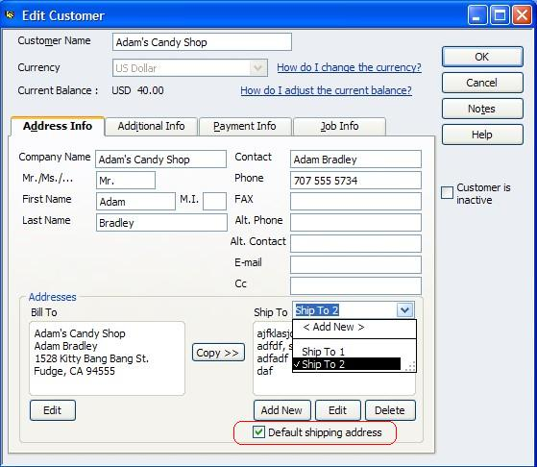
If you want to change the Ship to Address displayed in QODBC, you need to change the default Ship to Address in QuickBooks first (as below). And then you could get it in the ShipToAddress field in Customer table using QODBC.

- Accessing QuickBooks remotely with the QODBC Connector

What is it?
The QODBC Connector is a distributable utility that connects calls from your InterWeave Smart Solution to your QuickBooks Company file (the database).
How does it work?
The QODBC Connector contains a lightweight embedded web server, which listens for HTTPS requests originating from your InterWeave Smart Solution and then parses that request to the QuickBooks QODBC software driver (this is OEM’d and in your QuickBooks currently). Each request contains the XML data to be communicated to QuickBooks. The QODBC drivers then parses request to the QuickBooks SDK with MSSQL calls or QB XML calls.
How do I set it up?
The Remote Connector is available for both QuickBooks Online or QuickBooks Desktop hosted on a Windows 2012 or 2016 Windows Server from InterWeave. Please contact your InterWeave Sales Representative.
What does it cost?
The QODBC Connector cost $200 annually for the runtime license.
SSL Security
InterWeave Smart Solutions use SSL Security to encrypt all data transmitted across the network, ensuring that the QODBC Connector can publish outgoing request and read incoming requests in a secure manner. This prevents unauthorized parties from accessing any of your QuickBooks data. The connection from the QODBC Connector and the QODBC software drive is https.

- Managing Integration Timelines

How fast may I expect the Integration to be completed?
The integration timeline is at the customers speed — it is directly regulated by:
- the quality and amount of your data, duplicates, special characters, loading historical data, etc., and the number of flows you have selected.
- As we have over 100 flows and 300 configurable options to choose from, we recommend a phased approach so you may manage expectations.
Phase 1. Data de-dup in Salesforce is Job 1. Salesforce allows multiple Account names (not unique).
QuickBooks Customers are always unique—so you need to run your reports or exports, compare and match them to QuickBooks. Clean data allows for a very clean Integration. Look on the InterWeave Exchange for a vendor to assist.
Phase 2. Connect your QuickBooks. We have worked with many Managed Service Providers who host customers QuickBooks and customers who have the QuickBooks Company file running on their own internal server (ex. MS 2012 or 2016 Server). We work with a QuickBooks hosting company—www.trapponline.com—whose price points are excellent, and they know the applications (Salesforce/InterWeave/QuickBooks) very well. We highly recommend them.
Phase 3. Salesforce encrypted fields and API limits. If you have selected the InterWeave Payment Gateway, contact your Salesforce Sales Representative and ask to have encrypted fields turned on. Secondly, if you will be loading history into Salesforce or bulk loading Salesforce from QuickBooks, contact your Salesforce Representative and ask to extend you daily API calls to 50,000 per day for 7 days. This should allow time to load your Salesforce.
Phase 4. Group your flows in a logical/process manor (Salesforce/QuickBooks/Salesforce). When building out your configuration, there are logical groupings that allow you to test quickly are:
- Basic Integration. Accounts to Customers, Opportunities to Invoices and Products to Items.
- Advanced Integration 1. Additional flows (Opportunities to Sales Orders, Receipts, Estimates, etc.).
- Advanced Integration 2. Account to Vendors, Opportunities to Purchase Orders.
- Additional files. Add and integrate multiple QuickBooks Company files.
This approach allows you to set expectations internally and gives all a working plan to measure by.
Phase 5. Bind and move to Production. If you have selected bi-directional integration, we bind Accounts, Opportunities and Products in Salesforce to Customers, Invoices and Items in QuickBooks. Then we move you to production. You set the timing of the flows and your Solution runs 24/7/365.
Phase 6. Monitor and Customise. Now that you’re in production, to add custom fields in Salesforce connecting to QuickBooks, log in, stop your flows and then select Edit Company File to connect custom fields in Salesforce that you have created to fields in QuickBooks.
Support is available for all customers via our support site, email, phone and Zoom calls. If you are having an issue, we have a full library available at https://help.interweave.biz/ – register and review at your leisure. Welcome to the award-winning, InterWeave, the on-demand service designed for you to manage your Solutions, integrate with other systems, and even build your own Solution.

- Change your Password in your InterWeave Solution

Here you go:
- Open www.interweave.biz
- Click on Customer Login link. Integration Portal will open.
- Click on Edit Company Profile link (left bottom corner of the image).
- Enter your credentials and click “Load Company Profile” button.
- After profile is loaded click on “Next” button and navigate (using “Next” button) to the last page that has “Save and Finish” button.
- Change the SF password on that page,
- Click “Save and Finish”

- How to Use Bulk Load Utility Flows in InterWeave Integration Manager

NOTE: Turn off Scheduled flows before starting Utility flows!!!
UTILITY FLOW DEFINITION
There are 2 types of Utility flows:
- Bulk Load flows (with DR or DRS at the end of the flow name) DR = Date Range or DRS = Date Range & Size (Check radio button “Scheduled”)- for Bulk Load by period (Date Range) and batch size (S).
- Single transaction flows (with N or NF at the end of the flow name) N = Name/Number (Check radio button “Single Run”) – for one time particular transaction sync or testing (Account/Opportunity/Product/Quote… etc.)
In order to use Utility flows you will need to:
- Login into your ISP (Interweave Integration Solution) flows manager at (http://iw0.interweave.biz:8080/iw-business-daemon/IWLogin.jsp) – just type in your username and password and click Login button.
- Run one of Utility Flows (second low section of the screen) to test flow.
Please refer to this video for details: http://www.youtube.com/watch?v=S7crX_OEEpc&feature=channel&list=UL
(Production and Utilities Flows are show on 4 min of the video)
HOW TO RUN BULK LOAD FLOWS
Bulk load flows are marked with DR or DRS at the end of flow’s name.
Flows to use for SF to QB direction: (all flows are DR type except Account flow)
For Customers: SFAcct2QBCustDRS
For Items: SFProd2QBItemDR
For Invoices: SFAcctOpp2QBInvoicesDR
For Sales Orders: SFOpp2QBSODR
For Sales Receipts: SFOpp2QBSRDR
For Vendors: SFAcct2QBVendorDR
For Purchase Orders: SFOpp2QBPODR
Flows to use for QB to SF direction: (all flows are DRS type)
For Customers: QBCust2SFAcctDRS
For Items: QBItem2SFProdDRS
For Invoices: QBInvoices2SFAcctOppDRS
For Sales Orders: QBSO2SFAcctOppDRS
For Sales Receipts: QBSR2SFAcctOppDRS
For Vendors: QBVend2SFAcctDRS
For Purchase Orders: QBPR2SFAcctOppDRS
IN ORDER TO RUN UTILITY FLOWS YOU WILL NEED TO:
- Login into your ISP (InterWeave Solution Portal) Integration Flows Manager at (https://iw0.interweave.biz:8443/iw-business-daemon/IWLogin.jsp) – just type in your username and password and click Login button.
- Stop any started scheduled flow(s)
- Click on the flow you want to do a bulk load with.
- Fill in 3 opened fields below Utility Flows section
  - BatchSize
  - EndDateTime
  - StartDateTime
- Set Counter of the flow (second column from the right) to 0
- Check Start Checkbox (second column from the left) and auto-refresh checkbox (right top corner of the page – it will refresh manager’s page every 5 seconds)
- Click Submit button to run flow
- Monitor flow results in a log (the log is accessible by clicking on highlighted number/number in Runs column for this flow)
- Restart scheduled flow(s) if needed after bulk load is completed
- Logout from Integration Manager
Please refer to this video for details: http://www.youtube.com/watch?v=S7crX_OEEpc&feature=channel&list=UL
(Production and Utilities Flows are show on 4 min of the video)
All DRS flows have 3 parameters:
BATCH SIZE:
Recommended values for QB to SF direction:
- For Customers: QBCust2SFAcctDRS = 4 if customer contacts also are loaded from QB to SF; 20 otherwise
- For Items: QBItem2SFProdDRS = 25
- For Invoices: QBInvoices2SFAcctOppDRS = 4 (with line items) or 8-24 otherwise
For SF to QB direction batch size is controlled by SF. It is recommended to use 100 for any flow.
INTERVAL:
StartDateTime, EndDateTime – interval that is supposed to be loaded.
Formats:
- YYYY-MM-DD – created date for Customers and Items, transaction date for Invoices – (use for history data bulk load)
- YYYY-MM-DD HH:MM:SS – last modified date/time for all types. 24 hours clock should be used – (use to catch up with current missing data)* – for unlimited period (QB to SF only!). Could be used in Start and End DateTime or in just one of them (Do not supported for transactions – Invoices, Sales Receipts, Sales Orders etc.!)
- SF to QB direction Date/Time format (UTC): 2022-01-30T00:00:00.0Z (YYYY-MM-DDTHH:MM:SS)
- QB to SF direction Date/Time format: 2022-01-30 00:00:00 (YYYY-MM-DD HH:MM:SS)
- For “QuickBooks Online” QB to SF direction Date format: 2022-01-30 (YYYY-MM-DD)
INTERVAL NOTE FOR INVOICE FLOW ONLY:
- If you put to StartDate and/or EndDate just date (YYYY-MM-DD) – Opportunity CloseDate is used
- If you put to StartDate and/or EndDate timestamp (YYYY-MM-DDTHH:MM:SS.MZ) and BatchSize is empty – LastModifiedDate is used
- If you put to StartDate and/or EndDate timestamp (YYYY-MM-DDTHH:MM:SS.MZ) and BatchSize is not empty – CreatedDate is used
EXAMPLES:
- EndDateTime=YYYY-MM-DD (or YYYY-MM-DD HH:MM:SS) – to load all records set something in the future (e.g. 2022-01-01 00:00:00) or exact date and time for specific period (e.g. 2012-10-01 00:00:00)
- StartDateTime=YYYY-MM-DD (or YYYY-MM-DD HH:MM:SS) – to load all records set something in the past (e.g. 2000-01-01 00:00:00) or exact date and time for specific period (e.g. 2012-01-21 00:00:00)
When each of those flows is started first time – Counter (second column from the right) MUST be equal to 0.
If you want to stop bulk load – just remember all 3 parameters and Counter to resume later.
It is recommended to run bulk loads after hours or on weekend.
GENERAL NOTES:
- SF to QB and QB to SF direction flows for any type of bulk load require to set Permitted sync Operation to Create Only in Profile (temporary change)
- SF to QB direction flows require to set Permitted sync Operation for opposite direction to None in Profile (temporal change)
- QB to SF direction flows do not requires to set Permitted sync Operation for opposite direction to None (no change in Profile)
- Before flow is started, it is beneficial to have auto-refresh checkbox checked – this will refresh manager’s page every 5 seconds so you can monitor the progress of the flow. The Counter column will show you the number of already finished runs – every run is equal a number of transactions defined by BatchSize. It will stop when there are no more records to process.
- Every new bulk load requires Counter (second column from the right) to be reset to 0.
- Counter shows how many batches of size “batch size” are loaded.
- If you want to stop a particular load and then start from the same place – you need just to restore the Counter to the value you’ve stopped the load with.
- Remember that utility flows parameters are lost after logging out.
- If you bulk loading QB Customers/SF Accounts with Contacts then BatchSize cannot be more than 4 otherwise you will get an LIMIT_EXCEEDED error:
- “Query executed; Result= sf:LIMIT_EXCEEDEDLIMIT_EXCEEDED: Cannot have more than 10 chunks in a single operation. Please rearrange the data to reduce chunking.LIMIT_EXCEEDED Cannot have more than 10 chunks in a single operation. Please rearrange the data to reduce chunking.”
- If you restarting any SF to QB DR/DRS flow – you need to clear Return String! (Return String is a Property on top of the batch size in the lower frame. It is not there when you first time configuring flow (setting up Batch Size, Start Date and End Date). It appears after first run and contains SF Query Locator. If you need to restart DRS flow – you need to clear it or logout and login.
We keep their request locator from Salesforce but they (SF) have a mechanism that expires session after some timeout period. Using the old query locator is causing “Query Locator” error. This error is very rare. In any case we will also put a locking mechanism in the infinite run of the flow after such error.

- Adding a sub-folder in MS Office to catch QODBC errors as they are generated

Adding a sub-folder in MS Office
The Salesforce accounts that are not bound will not be able to connect with their QB Customer counterpart, so a QODBC error message will be produced and sent to the SF User identified in their InterWeave Solution. In addition, when invoices are run for this SF Account, additional error messages will be produced (there is no customer).
As a first step, please create a sub-folder in your MS Office with a rule to collect error messages.
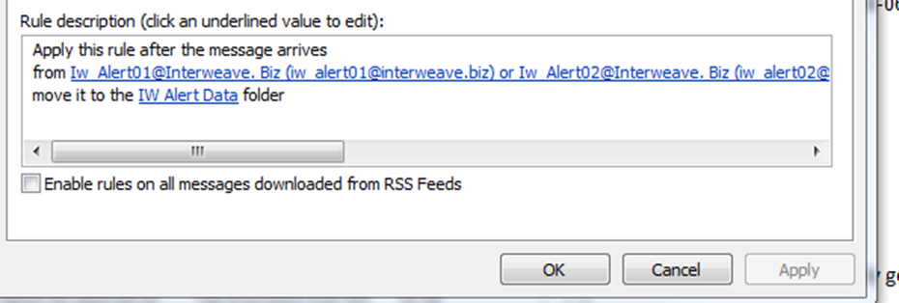
The rule.
You may need to create Iw_Alert01@Interweave.biz – Iw_Alert10@interweave.biz in your Contacts to support these email IDs.
This will contain all messages into a sub folder.
This is an example of an error.
Hello!
The following Error occurred during the execution of the Transaction Flow SFOpp2QBInvN:
2014-04-21 14:33:01.576 IW 2.41 TS SFOpp2QBInvN dmiller@.com ERROR XmlsqParams.statement
[QODBC] Error: 3000 – The given object ID “” in the field “list id” is invalid.
Initial Query Start Time: 2006-06-29 09:00:00.0 Final Query Start Time: 2006-06-29 09:00:00.0
Please take a look.

- Binding issues with your Salesforce Objects

Regarding that SO – I see that either Customer is not in QB or nor bound. I do not believe that Customer is not in QB – it is rather something is wrong with the binding. Please check the following:
There is just one Account with such name in SF.
- That Account has QB Full Name field populated with Customer Name from QB.
- QB Customer has Custom Field AccountID populated.
- Value of AccountID field matches Salesforce Account Id.
Please let me know if all these conditions are true.

- How to check Binding results

When we run a binding, binding flow takes the Salesforce Account Record ID and places this in the custom field “AccountID” that you created in your QuickBooks Customer Object. Same field can be activated for Vendor object as well. When you exposed that field (click on the Column title bar with the alt right button, then select “Customize Columns”) and drag and drop this from Available to Chosen. This column will now show which Customers have been bound and if blank, Customers which are not bound.

The next step is to correct your Salesforce Account Name to match the QuickBooks Customer name – we will then rerun binding till all match.

- DR Utilities - Date Range Utilities from QuickBooks to Salesforce

These settings would pick up Items from 01/01/2021 to 05/31/2021 (Put in next day to make sure we cover all of today).
The DR/DRS utility is used when you need to run a batch of a specific object. DR utilities are single run utilities that used for a small date intervals (couple of days top). DRS utilities are used to bulk load any amount of records. Parameters for both types are:
- StartDate or StartDateTime – beginning of the interval (exclusive)
- EndDate or EndDateTime – end of the interval (inclusive)
- Return String (optional) – has to be ignored
- Besides, DRS flows have additional parameter
- BatchSize – number of records for one batch load
- Recommended Batch Sizes may vary from 4 to 50 depending on record size
- Also DRS flows must start with a value 0 in a Counter Column
For example to load invoices from 1/1/2021 to 5/31/2021 you can use QBInvoices2SFAcctOppDRS with
- Batch Size 8
- Start Date format of 2020-01-01 00:00:00
- End Date format of 2020-05-31 00:00:00
These settings would pick up Items from 01/01/2021 to 05/31/2021 (Put in next day to make sure we cover all of today).

- How to determine Time Zone Shift

- Create a new test Customer in QB
- Run QBCust2SFAcctNF flow to send it to SF.
- Find out what QB LastModified timestamp is (in SF) and copy it.
- Update Customer in QB (e.g. change or add phone number).
- Run flow QBCust2SFAcctDRS switching it to single run mode (5thcolumn in IM) and using the following parameters:
  - BatchSize – 5
  - EndDateTime – 2022-01-01 00:00:00
  - StartDateTime – Paste the QB LastModified from #3 removing .0 at the end so format should be exactly as in #b above (YYYY-MM-DD HH:MM:SS)
  - Check if QB Lastmodified in SF has changed. If yes – you are done and no Time Zone Shift required
  - If it has not change – reduce StartDateTime for 1 hour (e.g. if it says 11:43:56 make it 10:43:56) and run the flow again.
  - The number of attempts (#7) until QB LastModified changes is your Time Zone Shift. If for example you reduced StartDateTime 4 times – your time zone shift is 4. The biggest number I’ve seen is 22. If you made 22 runs and no luck – please stop the process and let me know.

- How to Connect to Sage 50

Please see generic instructions below.
In order to restart connector after rebooting server you need:
- Login to Sage server as accounting.
- Open folder Sage2021 on desktop.
- Right click on PeachtreeImportExport.exe and select Run As Administrator
- Sage 50 should not be started!
- On different computer open http://www.interweave.biz and click on Customer Login link (right top corner)
- Put login credentials – Username customername@youremail Password
- Click on the flow PTCust2SFAccountIRS.
- Enter parameters – StartId, EndId, BatchSize 1 and click Submit in the lower frame
- Click on Single Run radio button for that flow, check Start checkbox and click Submit
- Return back to Sage Server and you should see Sage 50 started and credentials box opened. Enter password for interweave user (Interweave15)
- Go back to the browser and logout from flows.

- Checking on Required Fields in your Authorize.net

If your not getting the a result when your processing real-time payment or credit transactions in your Authorize.net, the first step is to check the Required Fields in your Authorize.net. Select Account/Settings/Transaction Format Settings/Payment Form/Forms Field. There will be 3 columns here; Edit/Visible/Required. You need to make sure the fields you have checked as Required, are in your Transaction Object in your CRM.

- Creating Invoice Numbers in Salesforce or QuickBooks; once decided - you can't change

If an Integration is not sending invoice numbers to QB – it is reading them from QB after it is created. So with your setup (QB Ref Number is generated in QB) it cannot fix the issue. The change to Invoice number sequence could happen only if somebody manually created an invoice with a new sequence start number. For example if your last Invoice Number was 2033 and I create an invoice manually and assign a number 2033-1 – QB will generate next invoice number as 2033-2, 2033-3 etc. More of it – if your last invoice number was 4789 and you create manually the invoice 2033-1 – QB will continue generating for next invoices 2033-2, 2033-3 etc. More dangerous situation – if you had a gap in invoice numbers like 11, 13, 14 ,15 etc. and decided to create invoice #12 – QB will continue generate numbers for next invoices as 13, 14 ,15 etc. so you’ll have duplicate numbers, which is very dangerous if integration is running. Long and short:
- Never create Invoices manually with numbers that can reset number generator or (if it is critical) always manually reset generator back (see #2 below).
- To reset number generator back you need manually create an invoice with the number you want to continue with. For example – if the last invoice was #2033 – create the one with #2034. If it was 4789 – use 4790. Updating existing invoices will not help! You can delete that dummy invoice after integration creates next invoice with a correct number.
Please instruct everybody who can manually create invoices regarding this issue.

- 30/60/90 not updating in my SF Accounts

If you are running InterWeave Smart Solutions Professional or Small Business, you will need to click on the QBtoSFAccounts on the SF Home Page (under Integration by InterWeave – top left). Clicking on this link will bring over the 30/60/90 information. You should do this every day.
If you are running InterWeave Enterprise or Ultimate – this is an automated function.

- How to Test your QuickBooks Connection

Login to flows.
- Click on the flow QBCust2SFAcctNF.
- In lower frame enter any random combination of letters as an AccountName (like gfdgfdgfdhfdh) and click Submit.
- Check Start (for that flow) and Auto-refresh checkboxes and click Submit.
- Wait until flow ends.
If result (rightmost column) will be 1/0 – connection is OK. If it will be 0/1 – connection is down.

- Generating a Transaction Key to access Authorize.net for Credit Card Processing

- Merchant Login (top right), enter Login ID and Password
- Select Account (top right), and in second section down on the right is API Login ID and Transaction Key
- Click on this and generate your Transaction Key. You need to put the Login, Password and Transaction Key in your InterWeave Payment Solution.

